Design Principles - Tell, Don’t Ask
# Source: AI Source: Provided by: [Data Path: Persons Table -> ID Column: 1, Name_En Column: Motasem Essam] -> From: [ChatGPT] on [1/23/2026]
“Tell, Don’t Ask” is the principle that objects should tell other objects what to do, rather than asking for their data and making decisions externally.
👉 Think of it like giving instructions directly to someone rather than interrogating them and deciding yourself.

🔑 Key Points
# Source: AI Source: Provided by: [Data Path: Persons Table -> ID Column: 1, Name_En Column: Motasem Essam] -> From: [ChatGPT] on [1/23/2026]
• Encourages objects to encapsulate their own behavior
• Reduces external logic that depends on internal state
• Supports high cohesion and low coupling
• Makes code more maintainable and easier to extend

❌ Bad Example
# Source: AI Source: Provided by: [Data Path: Persons Table -> ID Column: 1, Name_En Column: Motasem Essam] -> From: [ChatGPT] on [1/23/2026]
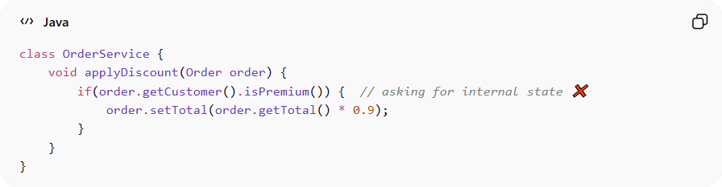
class OrderService {
void applyDiscount(Order order) {
if(order.getCustomer().isPremium()) { // asking for internal state ❌
order.setTotal(order.getTotal() * 0.9);
}
}
}
Problems:
• External code knows too much about internal state
• Violates encapsulation
• Makes maintenance and testing harder
• Adding new rules requires changing external logic

✅ Good Example
# Source: AI Source: Provided by: [Data Path: Persons Table -> ID Column: 1, Name_En Column: Motasem Essam] -> From: [ChatGPT] on [1/23/2026]
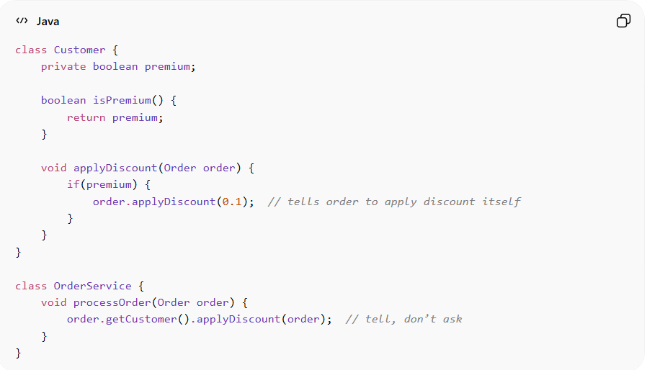
class Customer {
private boolean premium;

boolean isPremium() {
return premium;
}

void applyDiscount(Order order) {
if(premium) {
order.applyDiscount(0.1); // tells order to apply discount itself
}
}
}

class OrderService {
void processOrder(Order order) {
order.getCustomer().applyDiscount(order); // tell, don’t ask
}
}
Benefits:
• Objects manage their own behavior → encapsulation preserved
• Reduces coupling between classes
• Easier to extend and maintain
• Makes code more intuitive and readable

⚡ When to Apply
# Source: AI Source: Provided by: [Data Path: Persons Table -> ID Column: 1, Name_En Column: Motasem Essam] -> From: [ChatGPT] on [1/23/2026]
• Always — especially in object-oriented systems
• Works best with high cohesion and encapsulation
• Useful in service classes, domain models, and APIs
• Combine with Law of Demeter and High Cohesion for clean architecture

